39110636

Output:

7. **Consider a function f(X) = X3. Input is ‘N’ list. Each list contains ‘M’ elements. From the list, find the maximum element. Compute: S =(f(X1) + f(X2) + f(X3) + … + f(XN)) Modulo Z**

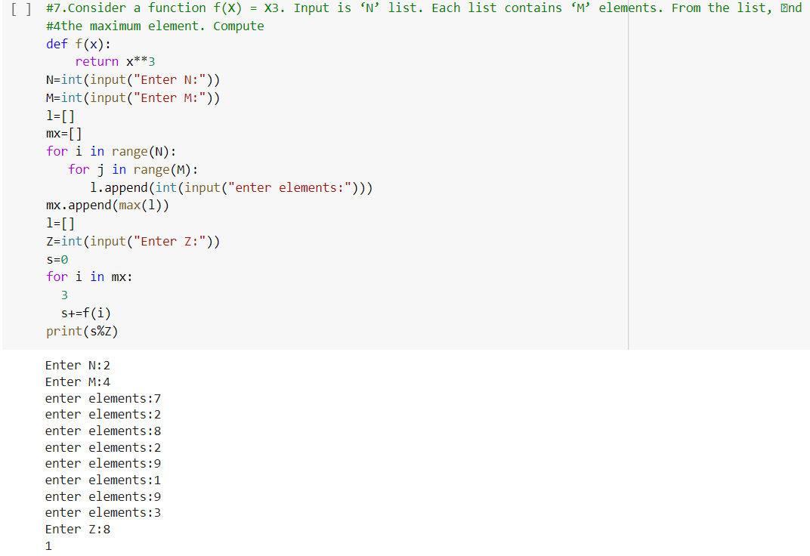

**8. Validate the Credit numbers based on the following conditions:**

**Begins with 4,5, or 6**

**Contain exactly 16 digits**

**Contains only numbers ( 0 to 9 )**

**For every 4 digits a hyphen (-) may be included (not mandatory). No other special character permitted.**

**Must not have 4 or more consecutive same digits.**

